Names: Partner 1 ____________________ Partner 2 ______________________

Worksheet: Exploring the Solar System Dataset
Neighborhoods – the place where you live is called your neighborhood.
Your neighborhood has many qualities about it that make it unique. Some neighborhoods are close to shops. Some might have good public transportation. Some might be near your school. If we wanted to explore and compare the different neighborhoods in which students live, we might want to ask a set of standard questions about neighborhoods like: the distance from school, number of public transportation routes serving the area, number of grocery stores, etc.

We all live in one larger neighborhood located within the Milky Way galaxy, called our solar system. In that solar system is our planet – our immediate neighborhood. There are other planets as well. Today we're are going to explore these neighboring planets and gather some information about them. The document we are going to use to store, organize and analyze the information we gather is called a spreadsheet.


Open the Excel file called PlanetDataSheet.xls. Your instructor has already entered some of the data categories that we will be gathering information for and, maybe, some of the data. When you enter data in the cells you can also enter text EXCEPT for the Distance from the sun and Orbital speed columns. Because we are going to organize those by numerical values, any text in the cells will be problematic.
Whenever you see a,
, you should be using the computer to perform the tasks.

Use the internet to find the rest of the data to complete your planet data sheet. If you're getting your data from two different sites, be careful to make sure the units are the same.

Science is about learning about the world. One of the ways scientists study the world is to collect data. Spreadsheets can be a very useful tool for gathering and storing data. It can also be used to work with the data. The Orbital speed in km/sec data is in kilometers per second. Let's have the spreadsheet convert these values to miles per hour.
Whenever you see a
, partners should write out answers together. If you don’t know the answer, ask another group for help before moving on.
One kilometer is 0.6214 miles.

- How would you convert 29 km to miles? ___________________________
__________________________________________________________________
There are 3600 seconds in an hour (60 seconds x 60 minutes).
- If one traveled 40 miles in a second, how would you calculate the number of miles you would travel in an hour?
___________________________________________________________________
Now let's have our spreadsheet do the calculations to convert the km/sec numbers to miles/hour.
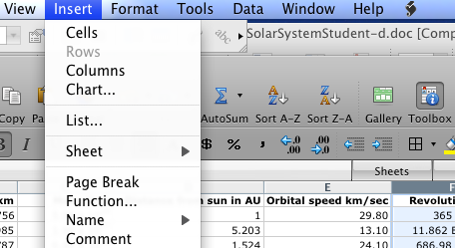
- Click on the box labeled "F" above the revolution period data, to highlight that entire column.
- Go to the Insert menu and choose column, to insert a column to the left of the highlighted one (by default).
- Label the cell in the first row of that column MPH.
- Now click on the next cell down (row 2) – the cell for the first planet.
- Type the = sign. This tells the spreadsheet an equation will follow.
- After the equal sign, type .0621, then the * symbol (multiplication), then 3600. These are constants that will not change no matter what planet.
- The last thing to do to multiply by a value that can change (depending on which row it is on). Add to your equation another * and then E2 (for the cell in row 2, column E) or you can just click on E2 and it will be typed for you.
- Push return and the cell will do the math for you.
- We could enter similar equations all the way down this column, but there is a quicker way to fill in the equations. You can either highlight the cell with the equation, and then drag down to highlight all the other cells where you want the equation to go…and then go to the Edit menu, drag down to Fill and then to the right to Down and let go. Alternatively, you can click on the one cell with the equation and then move (without dragging) your mouse to its lower right corner. When you see a cross, click and drag it down to cover all the cells you want to fill down (with the equation).
- If you click on any of the cells underneath you will see that the constants have not changed, but the cell reference row number changes depending on which row it's on.

The data can also be organized and sometimes it falls into patterns. Scientists often use patterns to make predictions.

Take a look at the way the spreadsheet is set up right now. The planets are organized by one criteria or parameter.

- How is the data organized?_______________________________________________________ _____________________________________________________________________________

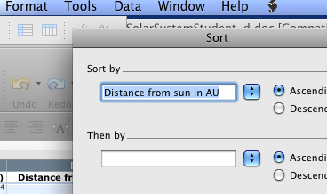
Let's organize the data in another way.
- Push the Command key and "A" (Apple and "A" on Macs) to select everything.
- Go the Tools menu and chose Sort.
- In the sort dialogue box, sort by Distance from the sun in AU (in ascending order) and click "OK".

- Can you describe how the planets are organized now?
_____________________________________________________________________________________
- What patterns or relationships do you see in the data?
_____________________________________________________________________________________

Let's use the related data to generate even more information.
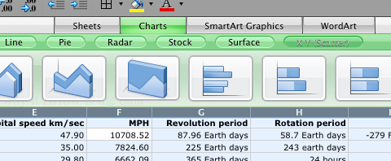
- Using your mouse, highlight the two columns of cells containing Distance from the sun data and Orbital speed data.
- Above the spreadsheet cells, click on the Chart tab and then click on the XY (Scatter) button that appears on the far right and then click on the chart icon with just dots, that appears on the left.
- Grab one of the corners of the chart that is created and drag away from the center, to make it bigger.
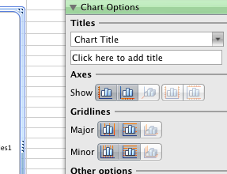
- To add detail to the chart, go to the View menu and choose Formatting palette so that the formatting palette appears.
- In the formatting palette, you can type Distance and Orbital Speed in the title box.
- Add major and minor grid lines to the X and Y axis by clicking the four icons in the palette.

- Is there a linear relationship between a planet’s distance from the sun and orbital speed? _______
- As one gets closer to the sun, is the orbital speed less or more than one would predict if the relationship was linear? _______
- Why do you think the orbital speed is faster than one might expect the closer to the sun a planet is? _______

Recently, scientists have been debating whether an asteroid located between Mars and Jupiter, called Ceres, should be called a planet. Whether or not it is called a planet, it still must obey the laws of astrophysics. Ceres is 2.9858 AU away from the sun.

- Using your data, estimate its orbital speed.______________________________________________

Applying what we have learned:
- If you wanted to collect information about all the different baseball teams and all the statistics for relating to each like wins, loses, home runs, etc., what might you use to organize and store the information? ____________________________________________________________________
- If you wanted to organize that information with the teams with the highest number of home runs showing up first what might you want to do? ___________________________________________
_______________________________________________________________________________
- What data might be related to the number of home runs data? ______________________________
_______________________________________________________________________________
- What could you do to find out if there is a relationship between two columns of information? _______________________________________________________________________________
_______________________________________________________________________________

These are some online animations of the solar system you might like to view:
Good solar system animation http://www.youtube.com/watch?v=9R5P9Y9gRYY
NASA video on scaling units http://www.youtube.com/watch?v=-6szEDHMxP4&feature=related

Exploring the Solar System Dataset by Mark Wenning is licensed under a Creative Commons Attribution-NonCommercial-ShareAlike 3.0 Unported License.

